Refrain Rhyme

🔹 What is Refrain Rhyme
# Source: Chatgpt (GPT-4-turbo) at [8/2/2025]
⚠️ Refrain rhyme is a poetic device, not a formal type of homograph.
However, homographs may be used in refrains when they recur with rhyme or thematic variation.

✅ Definition of Refrain Rhyme
# Source: Chatgpt (GPT-4-turbo) at [8/2/2025]
A refrain rhyme involves the repetition of a word, phrase, or entire line (called a refrain) at regular intervals in a poem, especially when that repeated element rhymes with other lines.
It is often found in:
- Ballads
- Songs
- Lyric poetry
- Chorus-based verse

🧠 Key Features
# Source: Chatgpt (GPT-4-turbo) at [8/2/2025]
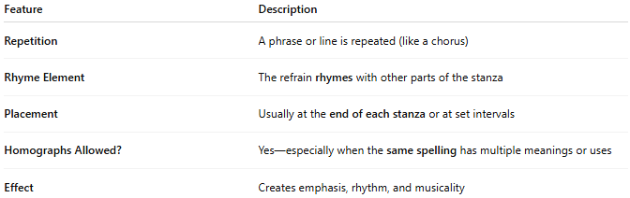
Feature | Description
Repetition | A phrase or line is repeated (like a chorus)
Rhyme Element | The refrain rhymes with other parts of the stanza
Placement | Usually at the end of each stanza or at set intervals
Homographs Allowed? | Yes—especially when the same spelling has multiple meanings or uses
Effect | Creates emphasis, rhythm, and musicality

📝 Example of Refrain Rhyme
# Source: Chatgpt (GPT-4-turbo) at [8/2/2025]
The wind was loud, the sky was red
The sea rolled high, the sailors fled
With cries that echoed overhead —
🌊 "The storm is near," the captain said.
The sails were torn, the anchor dropped
Their courage cracked, their hearts all stopped
The sky was black, the water bled
🌊 "The storm is near," the captain said.
✅ “The storm is near, the captain said” is the refrain
✅ It rhymes with red / fled / bled = refrain rhyme

🧪 Using Homographs in Refrain Rhyme
# Source: Chatgpt (GPT-4-turbo) at [8/2/2025]
Homographs can be repeated as refrains, often with shifted meanings or rhyming sounds.

✅ Example with “tear” (homograph: /tɛr/ vs /tɪər/):
# Source: Chatgpt (GPT-4-turbo) at [8/2/2025]
She didn’t cry, not even one tear
She closed her eyes, suppressed the fear
🌙 “No tear shall fall,” she said each year.
— “tear” can be used both as:
- Noun: drop of liquid from eye
- Verb: to rip
✅ Homograph
✅ Rhyme with fear/year
✅ Refrain rhyme

✅ Summary
# Source: Chatgpt (GPT-4-turbo) at [8/2/2025]
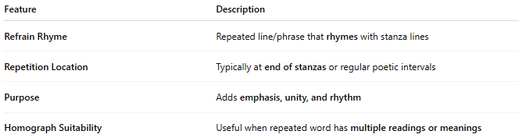

Feature | Description
Refrain Rhyme | Repeated line/phrase that rhymes with stanza lines
Repetition Location | Typically at end of stanzas or regular poetic intervals
Purpose | Adds emphasis, unity, and rhythm
Homograph Suitability | Useful when repeated word has multiple readings or meanings

